**Journey Through The Bible**

**EUNICE**

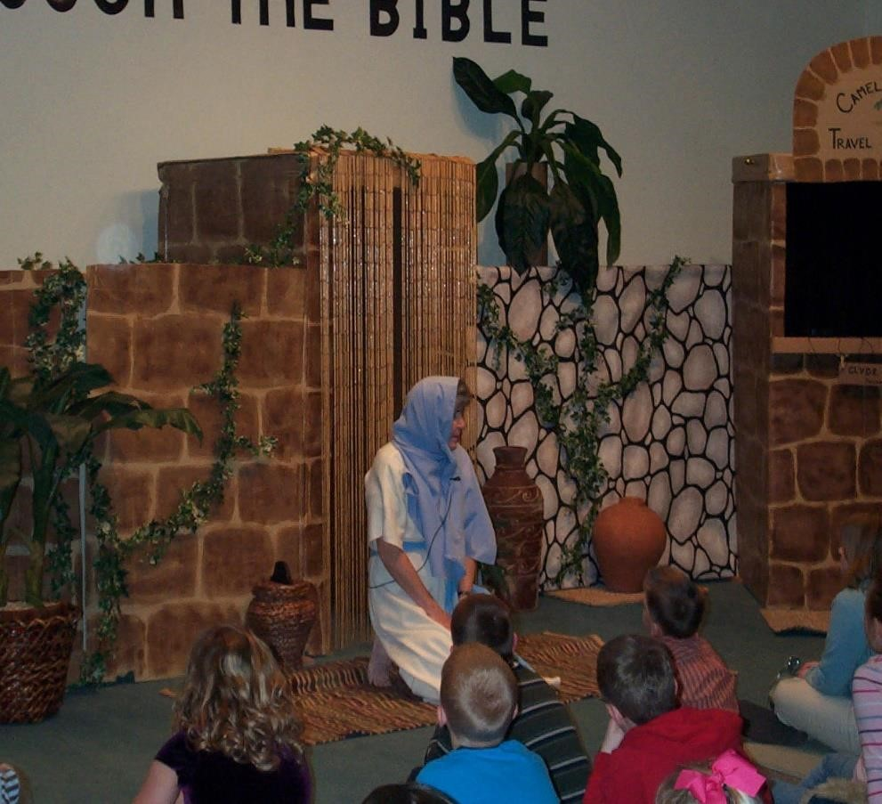

My name is Eunice. I am the daughter of Lois and the mother of Timothy. I am a Jewess from the town of Lystra. My husband is not a Jew.

I am so blessed to have a wonderful son such as Timothy. He is a faithful Christian. My mother Lois and I trained Timothy in the laws of the Old Testament. Timothy was converted to Christ and is like a son to the apostle Paul. Timothy cried for Paul when Paul was a prisoner.

Paul encourages Timothy to remain faithful and never to be ashamed of the gospel. He encourages Timothy to hold fast to the sound teaching that Paul preaches in the faith and love that are in Christ Jesus.

Paul reminds Timothy that God gives us a spirit of power and of love and of self-discipline.

I love my son Timothy very much and pray that he will do great things for God and always remain faithful to Him. There is no greater gift than a faithful Christian child.

My story comes from the book of II Timothy. Now I would like to ask you some questions. (Please prepare several questions to ask the boys and girls.)

**Memory Verse:**

Luke 10:27 -**You shall love the LORD your God with all your heart.**

# Song

Come and join us in our quest

To learn God’s word; you know it’s best. We learn from those of long ago

God’s truth that He wanted them to know.

Journey through God’s word tonight, The Bible teaches us what’s right.

Open God’s word and we will see

What the Journey Through the Bible reveals to Me

